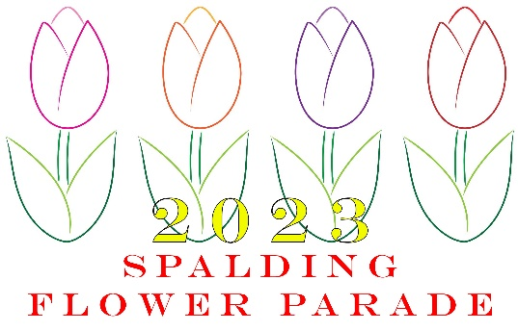
Spalding Flower Parade
7 Starlode Drove
West Pinchbeck
PE11 3TD
07516 902673

CRAFT STALL BOOKING FORM
Full name --------------------------------------------------------------------
Telephone number --------------------------------------------------------------------
Email address --------------------------------------------------------------------
Name/nature of business --------------------------------------------------------------------

I/we would like to reserve a craft stall for the 2023 Spalding Flower Parade on the Castle Sports Centre field on Saturday 6th May 2023
I require an inside stand (Marquee) at the price of £20 (please tick)

I require an outside stand at the price of £15 (please tick)

Tables/chairs not provided
Indoor stands are 3 metres wide
Set up will be anytime from 7.30am onwards, break-down expected around 6pm
Payment will be required approx.. 3 weeks before the event

Signed by ……………………………………….. on behalf of the business
Please send completed form via messenger or to email info@spaldingflowerparade.org.uk

